Chapter 1

1.1 Introduction
A quad-copter is a multi-rotor that is lifted and propelled by four motors. An android application is developed to control the quad-copter. The users may install the application to control the quad copter from their android devices.

The quad-copter is designed to hover and travel four basic directions, forward, backward, left and right. Wi-Fi has been used as the medium in between the android device (remote) and the Wi-Fi module (ESP 8266-01) which has been placed on the base of the quad-copter. It has a payload capacity of 2 kilograms.

Chapter 2
2.1 Scope of the project
We are making a quad copter with four brushless motors. It is controlled by an android application. A quad copter is a concept of a multi rotor having four arms. We are establishing the connection between the quad copter and android application using a wifi module that is placed on the base of the quad copter. Our aim is to implement 4 functions, i.e. Yaw, Throttle, Roll and Pitch.

2.2 User wise Functionalities
In our project the device interacts with the system, and vice versa.
A data string receives from the (ESC) is divided into part using the string function.
The message and the number are taken into consideration for sending values to each ESC’s.

Chapter 3

3.1 Design diagrams
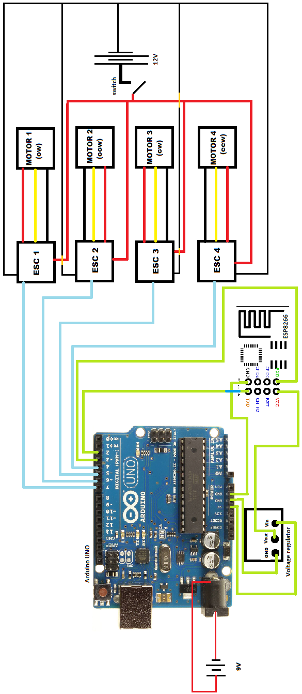
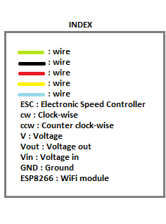
This diagram represents the connections of ESP, Gyroscope, ESCs to the UNO board and the power distribution.
3.2 Flow Chart
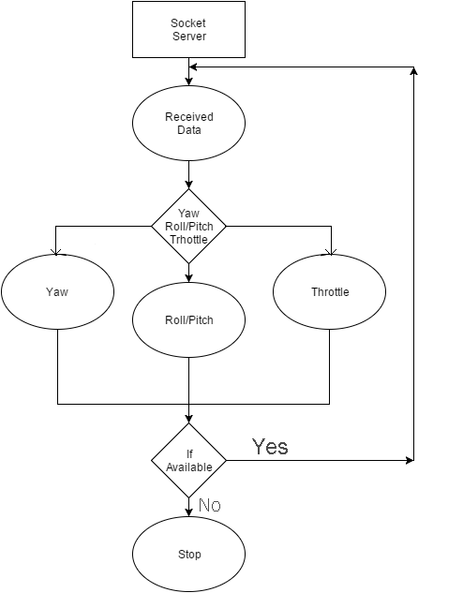

Chapter 4
4.1 Software requirement
Arduino IDE 1.0.6/1.6.8
Operating System - Windows XP and Higher Version

4.2 Hardware Requirement
- Quad copter Fiber Frame
- Brushless Motor – 1000kv 12v (x4)
- Propeller – 10X4.5 (x4)
- ESCs 30 amp (x4)
- Arduino UNO
- 2200 mAh 3 cell lipo Battery
- Linier voltage Regulator – AMS1117 3.5v
- wifi module - ESP 8266-01
- 9v Battery

Chapter 5

5.1 Screenshot

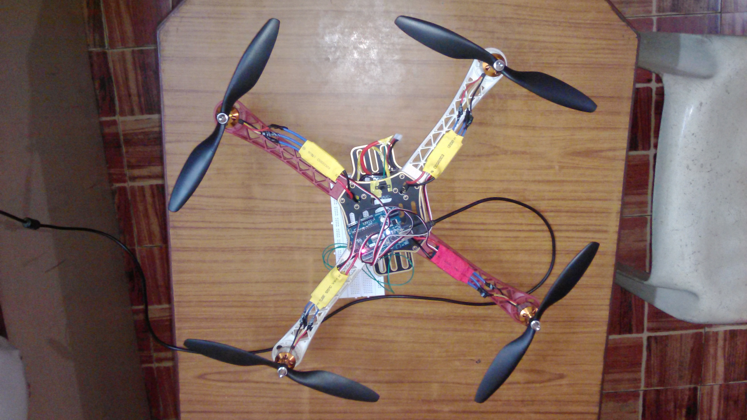

Chapter 6

6.1 Conclusions
The quad copter is programmed to take off and land from receiving throttle values from the android application. The four ESC’s are calibrated to achieve a stable flight as far possible. (ESP 8266-01) is used for communication between quad copter and android device.

6.2 Future Work
- We can set up a camera with the quad copter so that we can take pictures or videos from the top.
- We can set up an IR sensor with the quad copter.

